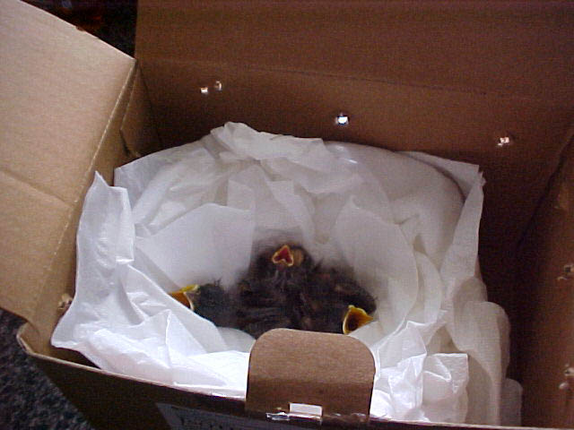
Temporary Care Instructions for Orphaned or Injured Birds - by Maureen Eiger, Category IIA - State and Federally Permitted Bird Rehabilitator.

Please do not give the bird any food or water! (Even if the bird is begging.)

Punch air holes in a cardboard box. Use a box appropriate to the bird’s size if possible. Usually a shoebox or other small box works great.

For baby birds – (no feathers yet) place them in a tissue paper lined cup or make a paper towel nest, place it in the bottom of the box. Keep the baby birds warm with a heating pad on low under the box, or a microwaved warmed rice sock placed in the box near the birds (but not on the birds.)

For all other birds that have feathers, a cloth lined or paper towel lined box works well. You can roll up a paper towel and make it into a circular perch laid on the bottom of the box.

Keep the bird in a quiet place.
Leave the bird alone; don't handle or bother it. Keep children and pets away.

Remember - NO food or water.
Call a wildlife rehabilitator for further instructions.

You can find one listed by City or County in Virginia on the internet at-
http://www.dgif.virginia.gov/wildlife/injured/rehabilitators.asp

